Bundling
What is Bundling? Bundling is the ability to combine multiple proposals in CIM, similar to stapling several forms together and dropping it in campus mail to start the approval process. Since proposals are often dependent on the approval of other courses or programs, bundling is a feature that can enable all proposals to be approved together through a combined, expanded workflow.
When should I bundle proposals? The most common situation that would require bundling may be when a user wishes to propose a new program that contains three new courses. Another common situation that may call for bundling would be when a user wishes to update an existing program by adding newly proposed courses to it. The following documentation will take you through these scenarios. For a detailed explanation on bundling from CourseLeaf, go to their 7/28/21 video, Introducing Bundling (https://luc.courseleaf.com/videos/cim310-20210728/).
When should I NOT bundle proposals together? We recommend that users DO NOT bundle multiple proposals together that are not dependent on one another such as three separate new course proposals or multiple course change proposals that are unrelated. If bundled together and one needs to be rolled back, the process would roll back all of the proposals. Bundling should really just include proposals that are dependent on one another for approval. Bundling also only involves courses and programs; designation proposals are entirely separate and cannot be bundled together with other proposals.
-
BUNDLING NEW PROGRAM PROPOSAL WITH NEW COURSE PROPOSALS
Step #1 – Create Proposals for New Courses, but SAVE them, do not Start Workflow
Scenario: A faculty member wishes to propose a new program, Culture and Diversity, that will lead to a BA in Sociology. While this program will require mostly existing courses, it will also require new courses in SOCG, PSYC, and BUAD. The first step will be for the faculty member to create proposals for these new courses (SOCG 385 Diversity and Inclusivity, PSYC 220 Psychology in the Workplace, and BUAD 120 Diversity Training for Businesses) as one normally would in https://nextcatalog.umw.edu/courseadmin/
When done creating the proposal(s), select SAVE CHANGES. Do not select START WORKFLOW. This step will take place later once all proposals are ready to be bundled.
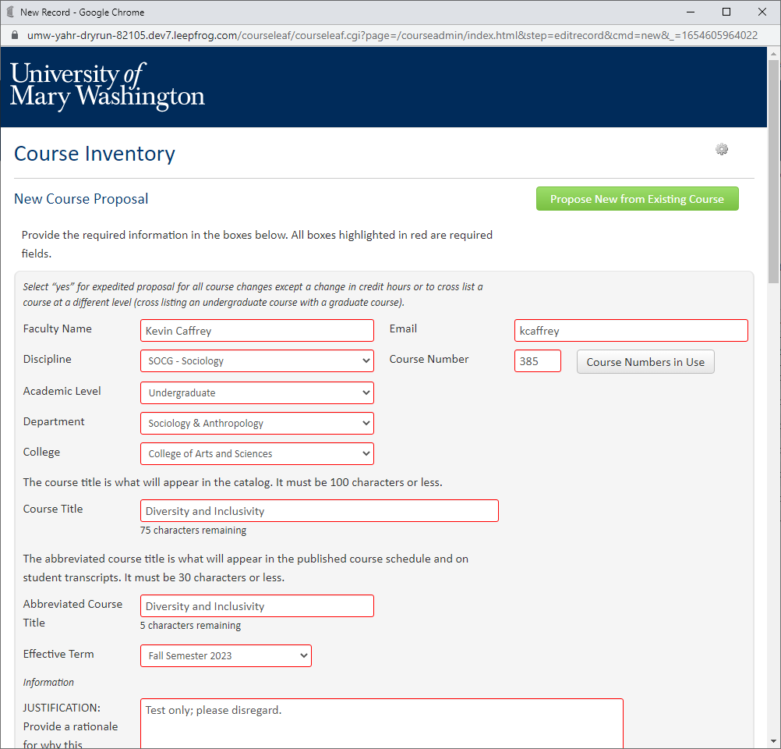
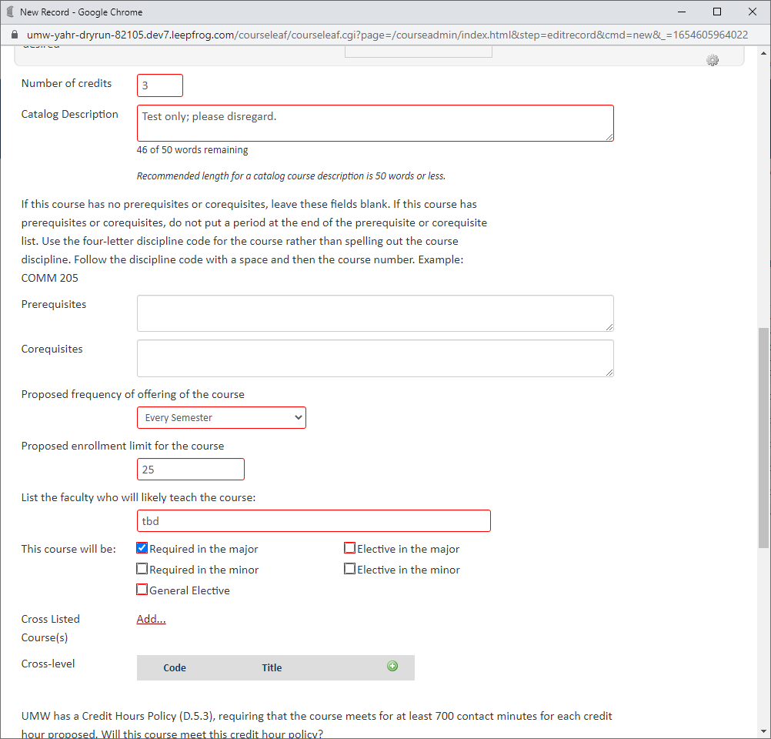
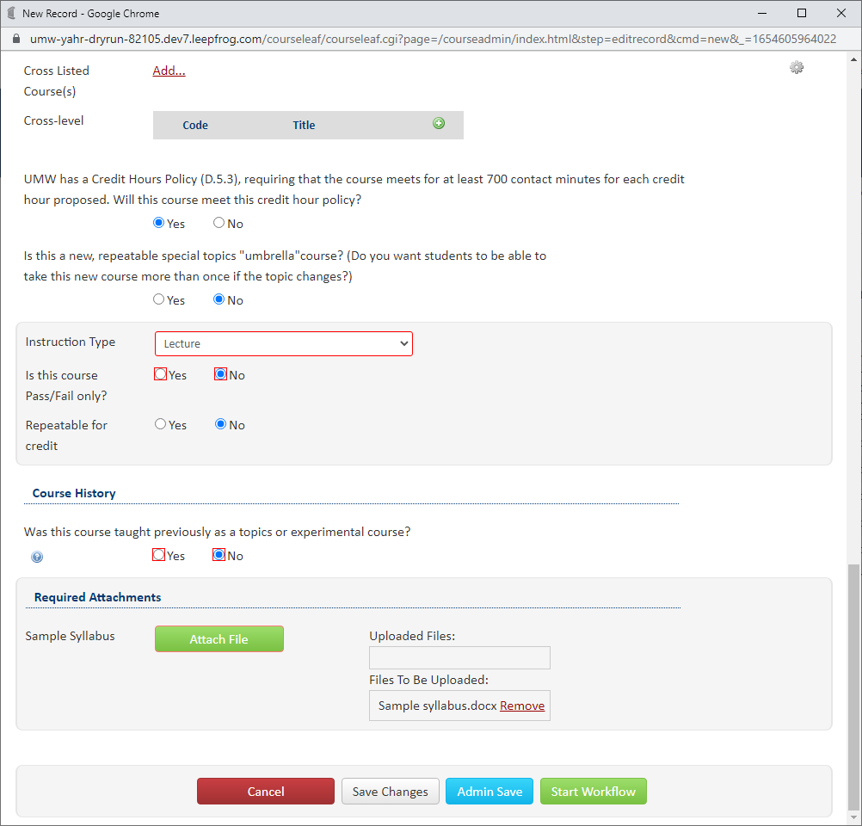
Once you’ve created proposals for all the new courses for the new program, go to https://nextcatalog.umw.edu/programadmin/ to create a proposal for the new program.

Step #2 – Create Proposal for New Program and use as PRIMARY PROPOSAL
You can either choose to build the new program from scratch or you can propose new from an existing program if there are similarities between the new program and an existing one (See [LINK TO DOCUMENTATION] for a how-to guide on this process if needed). In this case, we will propose a new program from an existing program since Culture and Diversity leads to a BA in Sociology and will share many requirements with that program. When working on this proposal, you’ll notice the new courses you’ve created are available as options to add as program requirements. After the proposal has been finished, it is time to select START WORKFLOW to create the Bundle.
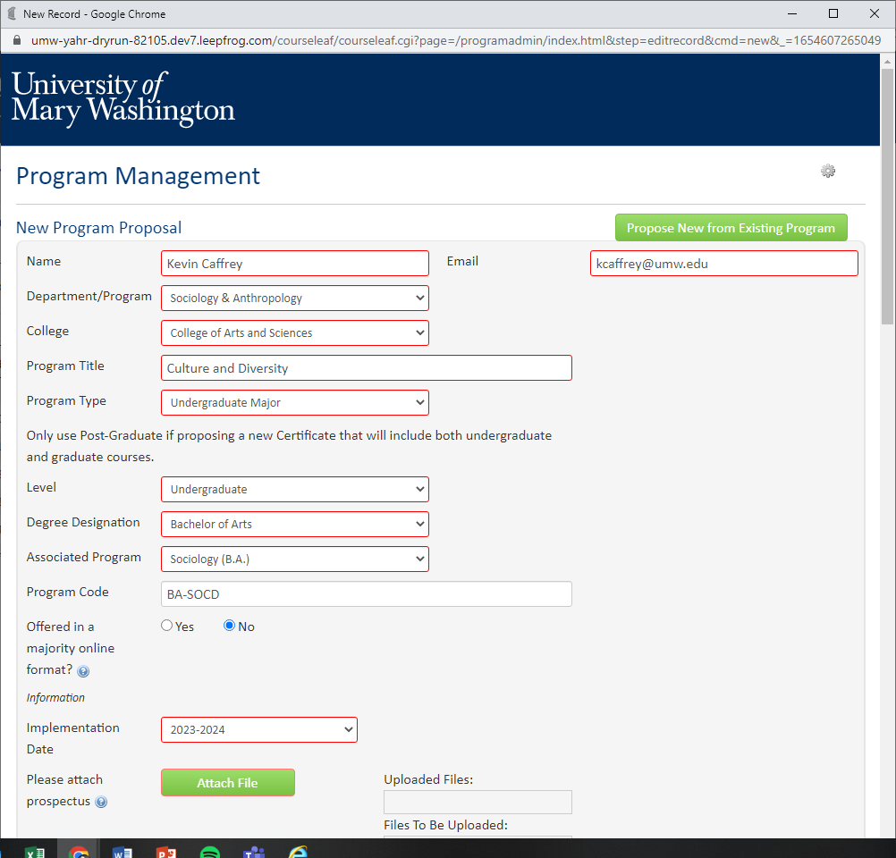
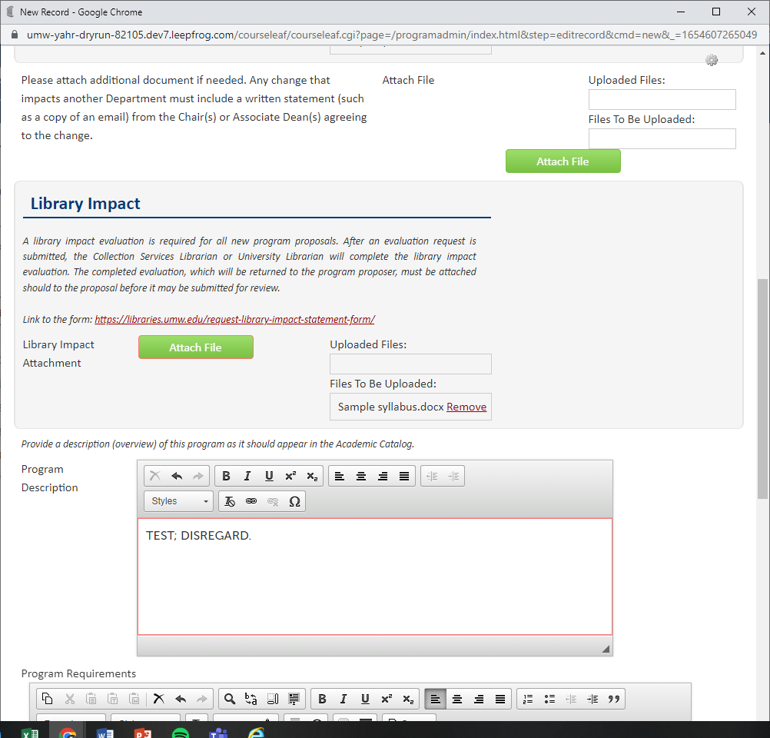

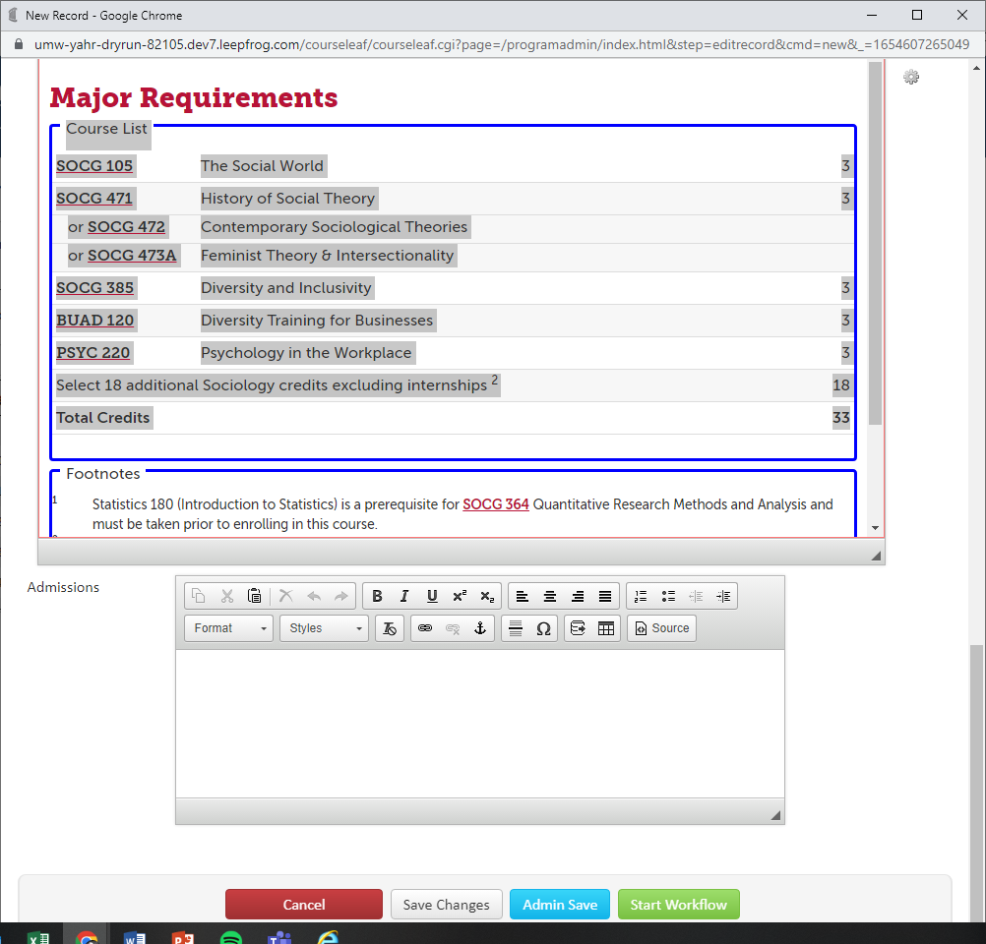
Consider this program proposal your primary proposal. This proposal’s workflow will be the basis for the merged bundle workflow. You will then be prompted to name this bundle and select your current active proposals (in this scenario, these are the new courses you’ve created) to add to it. These active proposals are considered target proposals. Then select START WORKFLOW.
Note: If you are looking to add a proposal that another user has created, you will not be able to do so unless you are the last user to have edited it. You can do this by going to the proposal in https://nextcatalog.umw.edu/courseadmin/, editing it, saving it, and then returning to the primary proposal to bundle. It should then appear as one of your options to add to the primary proposal for bundling.
-
Now the bundle of proposals (the new program proposal and the three new course proposals) have entered a merged workflow that combines shared steps so that everything can go through workflow together. Notice that the first step will begin with the SOAN Chair who will review the new courses and the new program to approve. The user should approve the primary proposal only. It will then move to the PSYC Chair to review and approve since a new PYSC course is part of the proposal.
Now that all the CAS Chair portions for a new program and new courses are approved, it will move on to the CAS Curriculum Committee, CAS Governance, and ultimately the CAS Dean who is responsible for final approval of new programs. Then the COB Associate Dean, COB Curriculum Committee, and COB Governance will approve the bundled proposal since it involves a new BUAD course as part of the bundle. Once those approvals are granted, the bundle finishes the workflow with the traditional final steps of UCC, UFC, and then the Provost’s final approval of the new program before being finalized at the Registrar/Banner level.

A great aspect of bundling is that the user has to view ALL proposals in a bundle before it can be approved. The eyeball icon will remind you if these bundles have been viewed yet or not. Once you view them, the icon will update and allow you to approve.

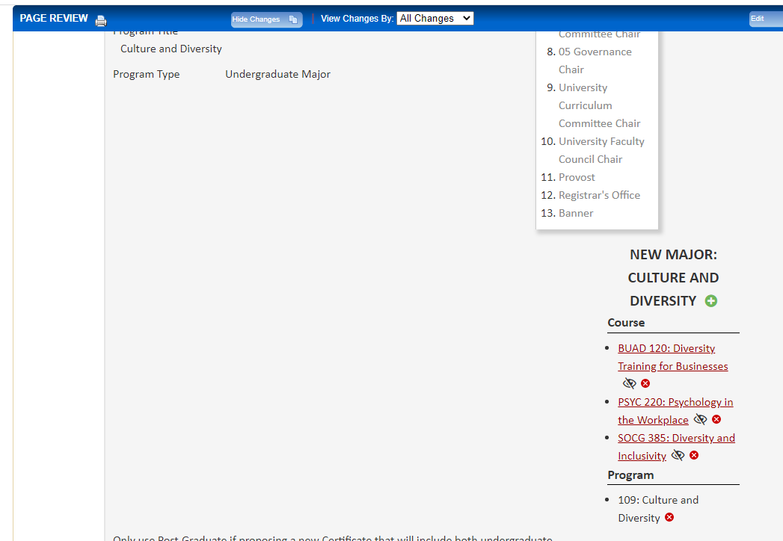

Users should approve the primary proposal after reviewing the other proposals. When a user approves the primary proposal, they are approving ALL the proposals in the bundle. If a user for example selected a course proposal that is part of a bundle, they would see the following and should select 109: Culture and Diversity to review everything.
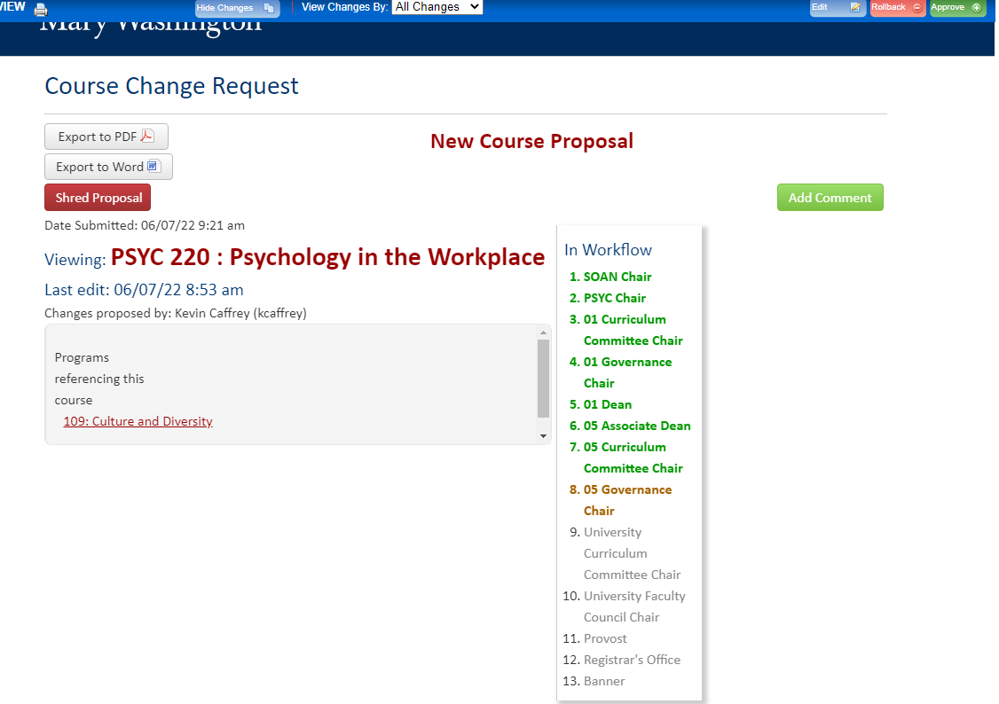

Rollbacks & Comments
If a user decides to Rollback the proposal, it rolls back everything. If a user adds a comment to the proposal, the comment will be added to all proposals.

Final Steps
When the bundled proposal finally gets to the last Banner step, since courses must sync with Banner, the proposal will unbundle so that these courses can be bridged to Banner. Programs do not sync with Banner, but will have a page created for the next Academic Catalog by the UMW CIM Administrator.
-
BUNDLING CHANGES TO AN EXISTING PROGRAM PROPOSAL WITH NEW COURSE PROPOSALS
Step #1 – Create Proposals for New Courses, SAVE them, do not Start Workflow
A faculty member wishes to create a new course to then add as a core requirement for an existing program. This is another good example of when to bundle. The first step, as it was above, will be for the faculty member to create a proposal for the new course. In the below scenario, the faculty member is proposing new course ACCT 195 Accounting and Intro Stats, and then wishes to add it as a core requirement for the Mathematics major. ACCT 195 would be proposed as one normally would in https://nextcatalog.umw.edu/courseadmin/ but select SAVE CHANGES as opposed to Start Workflow.
Step #2 – Create Proposal to Edit an existing Program and use as PRIMARY PROPOSAL
Through https://nextcatalog.umw.edu/programadmin/ find the program you wish to make changes to. In this case, we’re going to propose changes for the Mathematics major. After the proposal has been finished, it is time to select START WORKFLOW to create the Bundle.
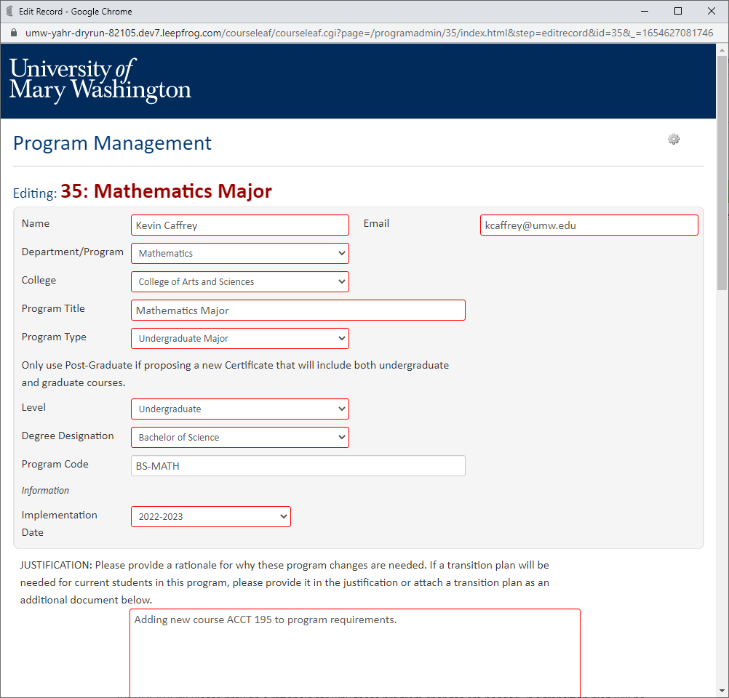
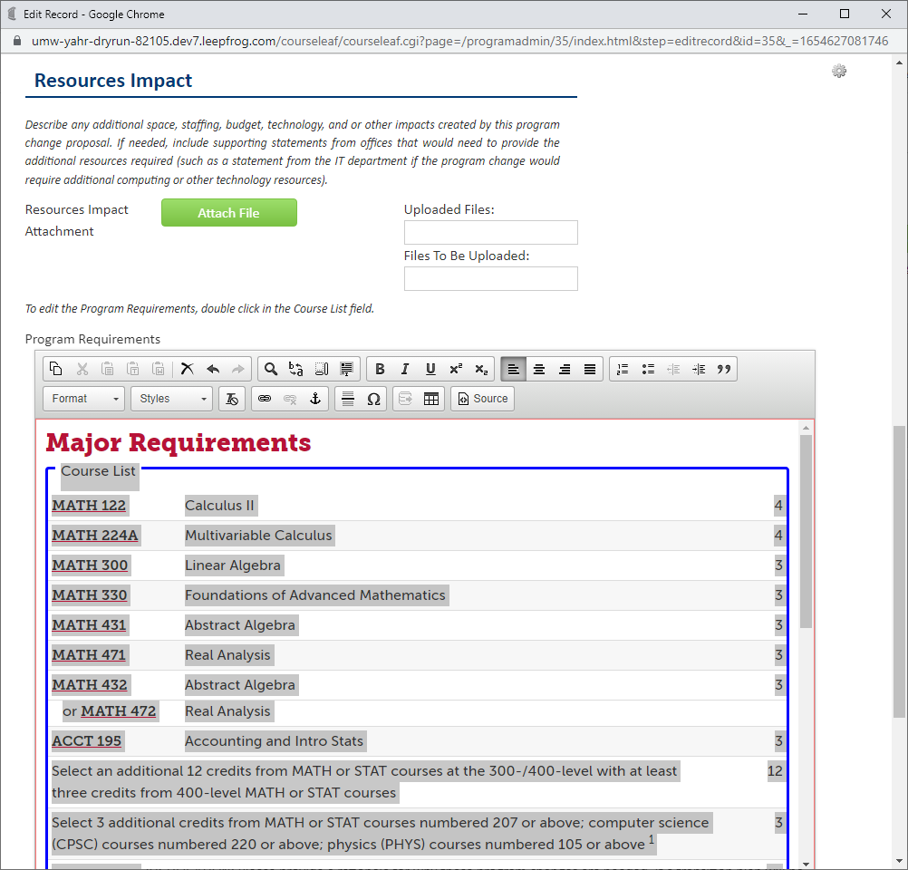
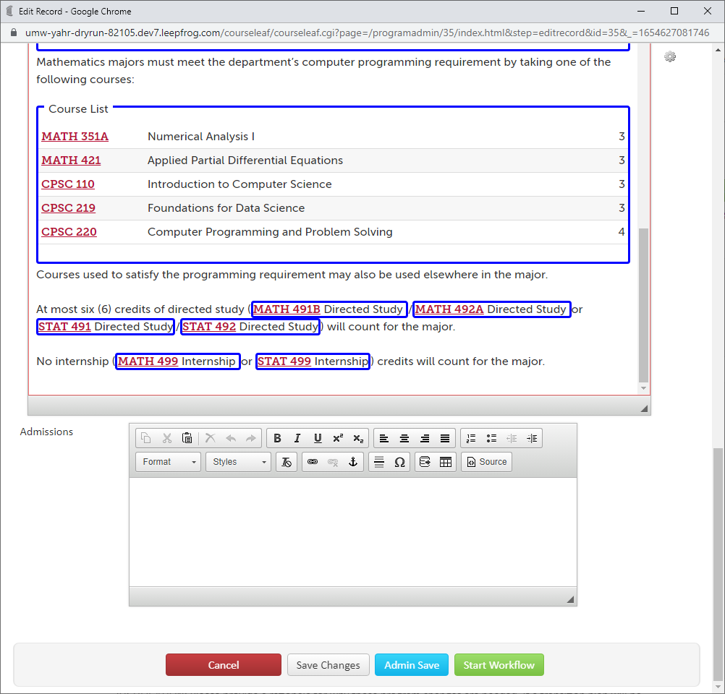
Name your Bundle and select the course that is part of the proposed changes:

Notice the merged Workflow, starting off with the MATH Chair and CAS curriculum and governance since the Math major is the primary proposal, and then going through the COB Associate Dean and curriculum since ACCT 195 is a COB course. Then the workflow will end at the traditional UCC, UFC, and Registrar/Banner steps:
