PROCEDURES FOR CHANGING ACADEMIC PROGRAMS

Guidelines for Submitting Proposals to Change Existing Academic Programs at the University of Mary Washington

August 2022

TABLE OF CONTENTS
CHANGE AN EXISTING ACADEMIC PROGRAM 2
APPENDIX A: EXPLANATION OF PROGRAM CHANGE PROPOSAL FORM FIELDS 4
APPENDIX B: PROGRAM CHANGE - PROPOSAL WORKFLOW 6

Important Procedural Note

All course program changes will take effect in the fall semester only. (No proposals will be accepted for a change that would start in the spring or the summer terms.) For a course program change action to be implemented beginning in the next fall semester, it must have received all required approvals no later than the posted deadline date, which is usually in late January or early February.

Please Note: proposals for new academic programs or current programs with significant modifications need to be approved by the October UFC meeting to allow for enough time to be approved by the BOV in November and then submitted for SCHEV approval by January². An example of a new program requiring SCHEV approval would be a new certificate program (i.e. undergraduate Criminal Justice certificate) or a new degree program (i.e. Bachelor of Fine Arts). An example of a significant modification to an existing program may include increasing or decreasing the total credit hours by more than three (3) credits from what was originally approved by SCHEV (i.e. a proposal to increase the credits required for the MSGA program from 30 to 36.). It also includes adding a new delivery format or ceasing to offer a program in the format in which it was approved by SCHEV as well as altering program requirements in a way that results in a fundamental change to the curriculum, purpose, focus, or identity of the program. To review all that constitutes new programs and/or significant program modifications requiring SCHEV approval, go to Academic Approval Policy at https://www.schev.edu/index/institutional/guidance-policies/academic-affairs-policy/approval-of-program-actions.

CHANGE AN EXISTING ACADEMIC PROGRAM

- Navigate to (URL)

- Click on the EDIT OR PROPOSE A PROGRAM login and enter the UMW user name and password. Once logged in, the following screen appears:
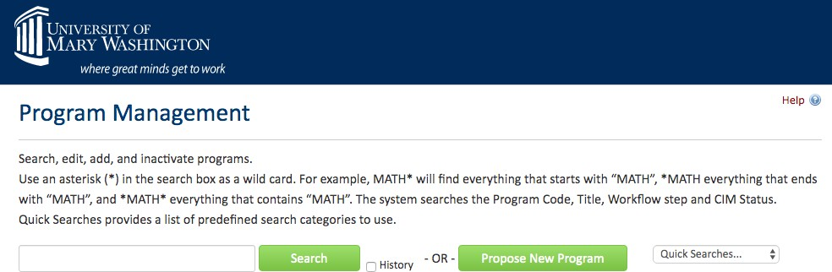

- Enter the name of the program to be changed in the search box. The result should look like the following screen:
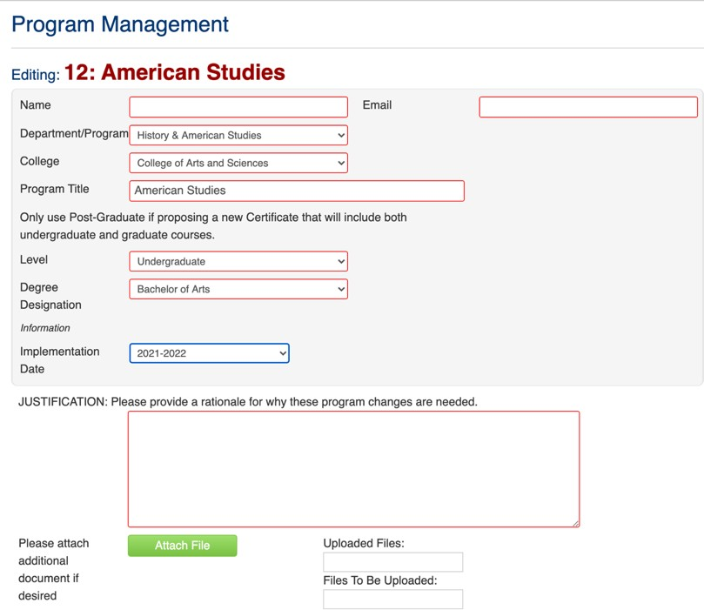

- Name and email refer to the person proposing the changes. Those would be filled in. Level and implementation date are drop down boxes with the relevant choices available. Level is undergraduate, graduate, and so forth. Implementation date would be the academic year when the proposed changes would start, with changes going into effect in the fall.

- See Appendix A for an explanation of each of the form fields you will see when proposing a to change an existing academic program.

- After all required information is provided, the start workflow button is selected to move the proposal to the first reviewer (Department Chair or Associate Dean). A proposal may be saved for continued work, cancelled, or submitted by selecting “start workflow.”

Once the proposal is in workflow, changes entered will display as green text. Deletions display as red strikethrough text.

See Appendix B for the full display of all steps in the workflow to change an academic program.

APPENDIX A: EXPLANATION OF PROGRAM CHANGE PROPOSAL FORM FIELDS

are required and must be completed in order to submit the form.
Fields outlined in red

Level
Undergraduate, graduate, or post-graduate. Post-graduate only applies to certificate programs that include both undergraduate and graduate courses.

Discipline
This is the four letter code used to identify subject areas offered at UMW (ENGL, MATH, SPAN, and so forth). The discipline will display as a drop down menu including the four-letter code and the associated disciple name (e.g. SOCG – Sociology).

Department/Program
The home department of the discipline offering the program. In the Colleges of Business and Education, there is no department. Or the generic “Business” and “Education” choices available under the department/program dropdown may be used instead of picking “no department.”

College
UMW’s three colleges are the choices available.

Program Title
The name of the major, minor, or certificate program being modified.

Degree Designation
The degree designation signifies a rank or level of educational attainment that is conferred on students who successfully complete all degree program requirements and degree conditions (such as achieving the required overall grade point average, the required grade point average in the major, and meeting the residence requirement). This field will contain the program’s existing degree designation (such as Bachelor of Arts).

Implementation Date
The academic year when the proposed program change goes into effect. The effective term is the fall semester of the next academic year (or a subsequent fall semester, if selected). This item is a drop-down box with choices provided.

Justification
An explanation for why the program changes proposed are needed. The reasons may be entered into the box or provided as an attachment. If an attachment is used, the writer might write “see attachment” in the justification box.

Resources Impact
If there are any space, staffing, budget, technology, and or other impacts created by the program change proposal, these should be described in a document that is attached to the proposal. If needed, include supporting statements from offices that would need to provide the additional resources required (such as a statement from the IT department if the program change would require additional computing or other technology resources). If here are no resource impacts, the part of the proposal would be skipped.

Program Requirements
The existing program requirements as listed in the academic catalog will be brought into the form. By double-clicking in the box containing the program requirements, changes can be entered by deleting existing courses, adding new courses, changing credits required, and so forth. Once the proposal is in workflow, changes entered will display as green text. Deletions display as red strikethrough text.

Admission Requirements
Some UMW academic programs have additional admissions requirements. If this is the case, a box displaying current admissions requirements will appear with the text as it is presently in the catalog appearing. By double-clicking in the box containing the admissions requirements, changes can be entered by deleting existing courses, adding new courses, changing credits required, and so forth. Once the proposal is in workflow, changes entered will display as green text. Deletions display as red strikethrough text.

APPENDIX B: PROGRAM CHANGE - PROPOSAL WORKFLOW

If approved | PROCESS STEPS | If rolled back
 | 1. Proposer logs in to CIM program, completes change program proposal, and submits.
 | 2. Department Chair (College of Arts and Sciences) or Associate Dean (College of Business and College of Education) – reviews and either approves proposal or rolls back (to proposer). **In the instance that the proposal contains significant modifications that would require SCHEV approval, the Department Chair or Associate Dean should consult with the Provost and inform Kevin Caffrey to add Provost approval to the workflow.**
 | 3. If approved, proposal goes to College Curriculum Committee.
 | 4. College Curriculum Committee – reviews and either approves proposal and sends to College Governance Council or rolls back (to Department Chair or Associate Dean).
 | 5. College Governance – reviews and either approves proposal and sends to University Curriculum Committee or rolls back (to College Curriculum Committee).
 | 5. University Curriculum Committee – reviews and either approves proposal or rolls back (to College Governance or to College Curriculum Committee).
 | 8. If approved by University Curriculum Committee, proposal goes to University Faculty Council.
9. University Faculty Council – approves proposal or
rolls back (to University Curriculum Committee). **Provost added to workflow if proposal contains significant modifications.
 | 10. If approved by University Faculty Council, proposal goes to Registrar’s Office for final check and to initiate Catalog update.
 | 11. Next Academic Catalog is updated.

