PROCEDURES FOR PROPOSING A NEW COURSE

Guidelines for Submitting Proposals to Create New Courses at the University of Mary Washington

August 2022

TABLE OF CONTENTS
PROPOSE A NEW COURSE 2
APPENDIX A: EXPLANATION OF NEW COURSE PROPOSAL FORM FIELDS 6
APPENDIX B: NEW COURSE - PROPOSAL WORKFLOW 8

Important Procedural Note

All course changes will take effect in the fall semester only. (No proposals will be accepted for a change that would start in the spring or the summer terms.) For a course change action to be implemented beginning in the next fall semester, it must have received all required approvals no later than the posted deadline date, which is usually in late January or early February.

PROPOSE A NEW COURSE

- Navigate to (URL)

- Click on the EDIT OR PROPOSE A COURSE login and to enter the UMW user name and password. Once logged in, the following screen appears:
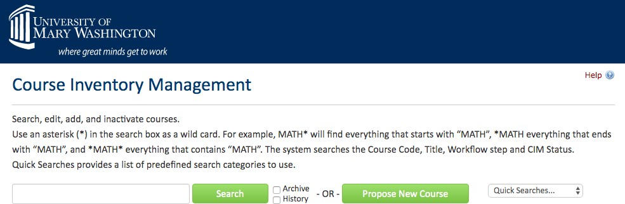

- Select “Propose New Course.” The result should look like the following screen:

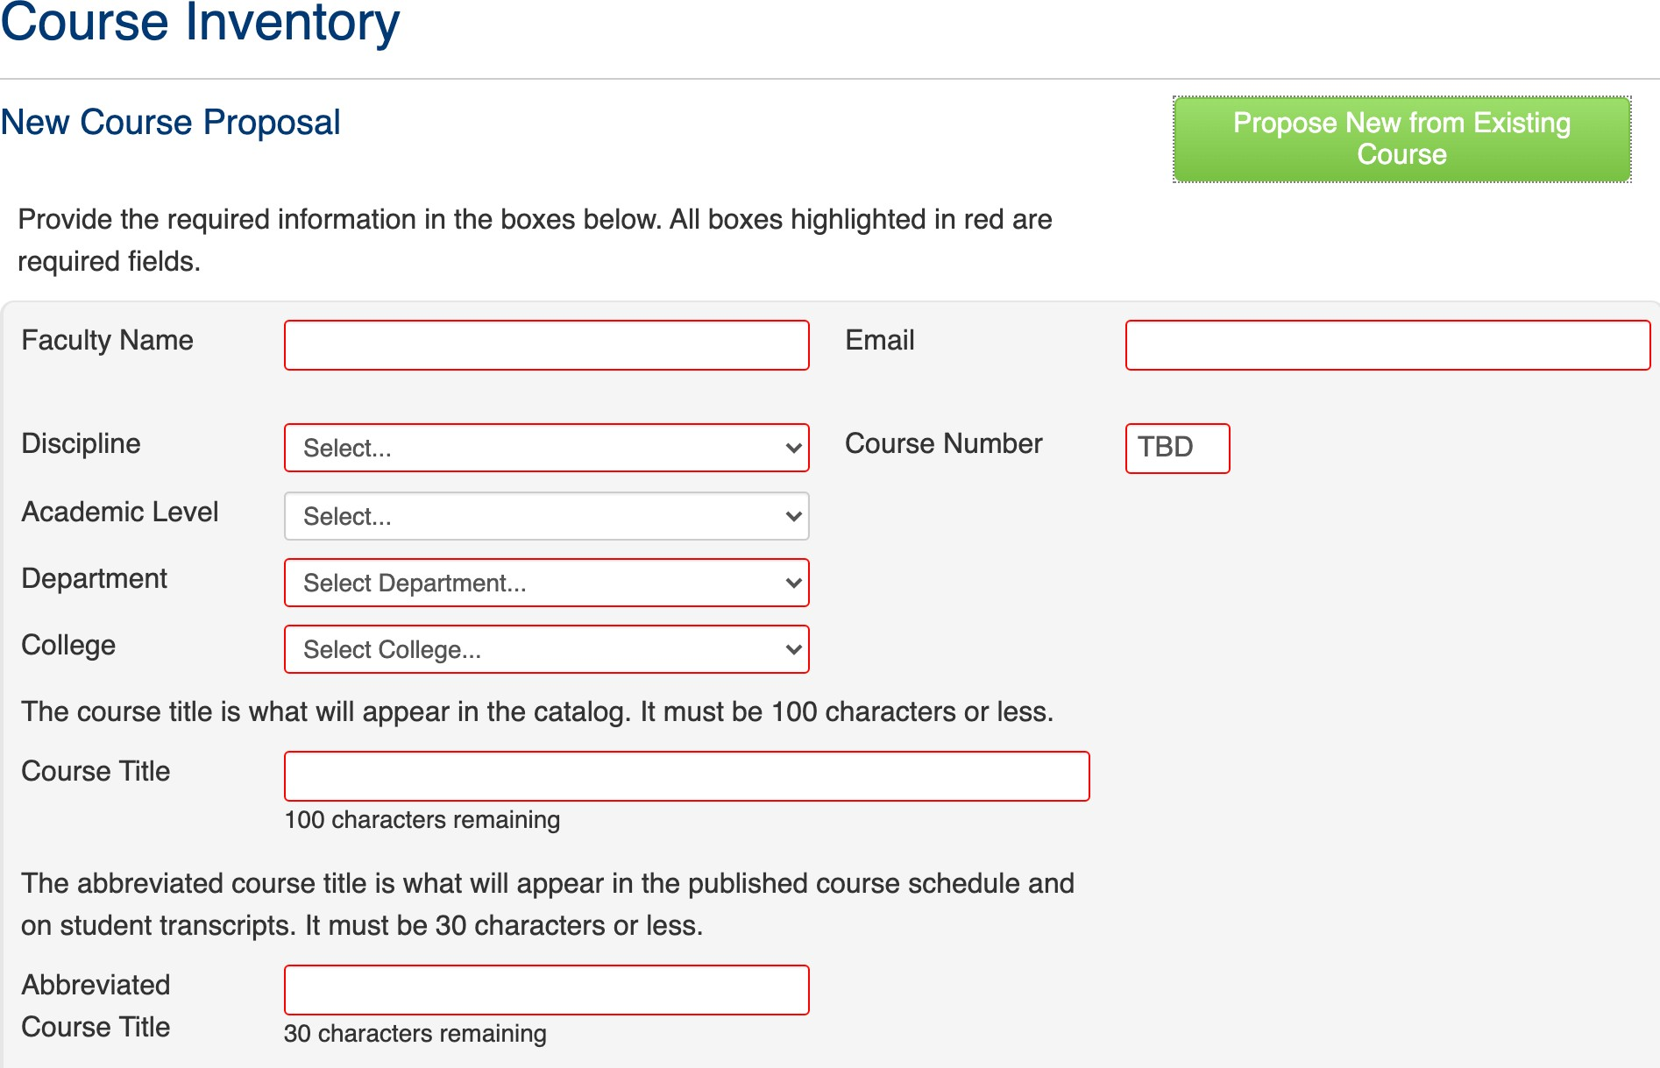
Provide the required information. See Appendix A for an explanation of each of the form fields you will see when proposing a new course.

Once you select the course discipline and academic level, a box called “numbers in use will appear.” By clicking on that box, you will see which course numbers are currently “taken” in that discipline. This feature allows you select a new course number that will not conflict with numbers already assigned.

For example, entering COMM as the discipline . . .

produces this list of numbers in use (this is just a part of the list to illustrate the functionality):
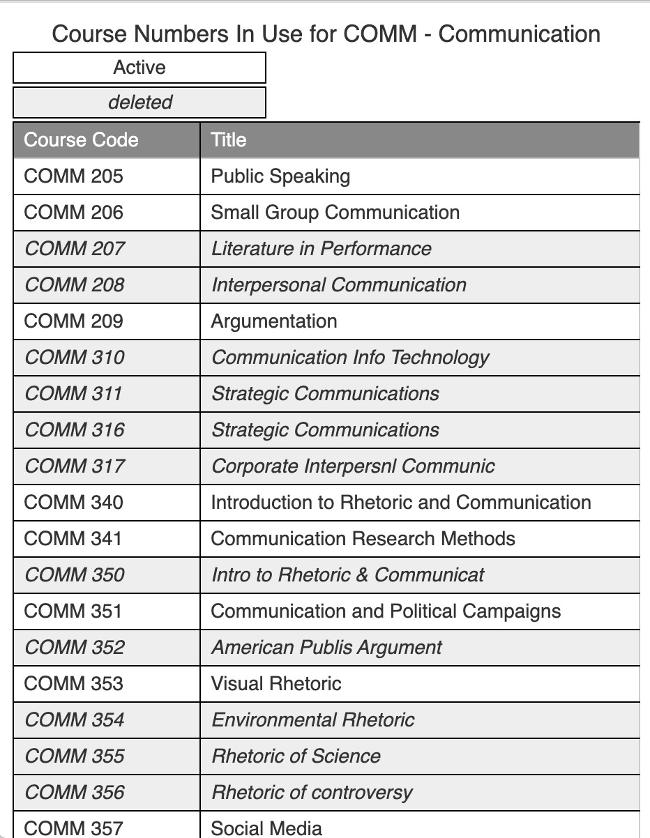

- When entering the proposed credit hours for the new course, answer this question:
If the answer is NO, this field will appear:
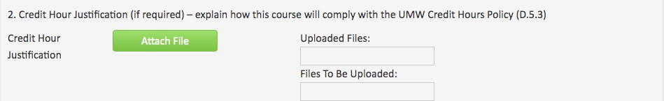

Provide the explanation/justification as an attachment.

- One part of the form requests information about course history, asking whether the course was taught previously as a topics or experimental course.
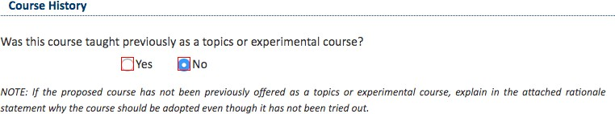

If “no,” the rationale statement should explain why the course should be adopted even though it has not first been tried out. If “yes,” questions about the course history appear.
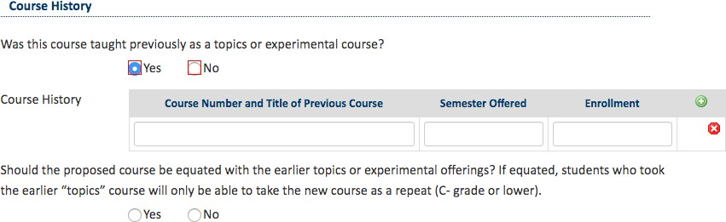

- After all required information is provided, the start workflow button is selected to move the proposal to the first reviewer (Department Chair or Associate Dean if in the Colleges of Business and Education). A proposal may be saved for continued work, cancelled, or submitted by selecting “start workflow.”

See Appendix B for the full display of all steps in the workflow to add a new course.

APPENDIX A: EXPLANATION OF NEW COURSE PROPOSAL FORM FIELDS

are required and must be completed in order to submit the form.
Fields outlined in red

Faculty Name and Email
The proposing faculty member’s name and UMW email address are to be provided.

Propose from Existing Course
This option would enable some fields of information to be copied from another course that is already in the system. This might be useful as a starting point for a new course or courses that will have similarities to a first one (such as a proposal to create a new course that would be cross-listed with an existing course).

Academic level
Undergraduate or graduate. Undergraduate courses are numbered 000-499. Graduate courses are 500-599. UMW does not use courses numbered 600 and above.

Discipline
This is the four letter code used to identify subject areas offered at UMW (ENGL, MATH, SPAN, and so forth). The discipline will display as a drop down menu including the four-letter code and the associated disciple name (e.g. SOCG – Sociology).

Department
The home department of the discipline offering the course. IDIS (interdisciplinary) courses must be associated with a home department. In the Colleges of Business and Education, there is no department.

College
UMW’s three colleges are the choices available.

Course Title
This is the full title for the course that will appear in the Academic Catalog. Do not use abbreviations or & (in place of the word and) in this title.

Abbreviated Course Title:
This is a 30 character short title that will appear in the schedule of courses and on the transcript. Abbreviations and & may be used here.

Effective Term
The date when the course action takes effect. For all course changes, the effective term is the fall semester of the next academic year (or a subsequent fall semester).

Number of Credits
The current credit hour value for the course. If the proposal seeks to change the course credit hours, insert the new credit hour number, answer the question about compliance with the credit hour policy and attach an explanation/justification if the response was if the response was “no.”

Catalog Description
The written course description as it will appear in Banner and the Academic Catalog. Course descriptions should be succinct; it is recommended that course descriptions be 50 words or less.

Prerequisite
Courses that must be taken prior to the course in question, or other qualifying conditions necessary before the student may enroll in the course (such as must be a major in a certain field or must have junior/senior standing). Use the four-letter discipline prefix (e.g. MATH) rather than spelling out the discipline name. Have a blank space after the four-letter discipline prefix and the course number. Do not use a period at the end of the list.

Example: MATH 201

Corequisite
Courses that must be taken simultaneously with course in question. Use the four-letter discipline prefix (e.g. MATH) rather than spelling out the discipline name. Have a blank space after the four-letter discipline prefix and the course number. Do not use a period at the end of the list.

Example: MATH 121

Cross Listed Course
For courses offered at the same level, this is the option for the same course to bear two separate discipline codes (e.g. CPSC/DATA 419). Courses cross listed at the same level must have the same title, course description, prerequisites, and corequisites. A note stating “Cross listed as . . .) will appear at the end of the course description in the Academic Catalog.

For courses cross listed across levels (an undergraduate course cross listed with a graduate course), the courses cross level listed may have different titles, descriptions, prerequisites, and corequisites. However, the graduate-level course expectations must exceed the expectations of the academic content of the undergraduate-level course with which the graduate course is cross-listed.

Proposed frequency of offering
From the drop down menu, select fall, spring, yearly, or alternate years. Yearly means both semesters each year. Fall or spring means only in that semester each academic year.

Proposed enrollment limit
Indicate if this course is proposed as one that will be taught in single or multiple sections.
State the enrollment cap (maximum) for the course. The help icon reveals the suggested course enrollment guidelines at UMW.

List faculty who will teach the course
Indicate full-time faculty by full name. If selected adjuncts will also teach the course, indicate that by the word “adjunct.” Do not list adjunct faculty by name (since many adjuncts do not teach continuously from semester to semester).

Rationale
An explanation of why the proposed new course needs to be added to the curriculum.

APPENDIX B: NEW COURSE - PROPOSAL WORKFLOW

If approved | PROCESS STEPS | If rolled back
 | 1. Proposer logs in to CIM course, completes new course proposal, and submits.
 | 2. Department Chair (College of Arts and Sciences) or Associate Dean (College of Business and College of Education) – reviews and either approves proposal or rolls back (to proposer).
 | 3. If approved, proposal goes to College Curriculum Committee.
 | 4. College Curriculum Committee – reviews and either approves proposal and sends to College Governance Council or rolls back (to Department Chair or Associate Dean).
 | 5. College Governance – reviews and either approves proposal and sends to University Curriculum Committee or rolls back (College Curriculum Committee).
 | 6. University Curriculum Committee – reviews and either approves proposal or rolls back (to College Governance or College Curriculum Committee).
 | 7. If approved by University Curriculum Committee, proposal goes to University Faculty Council.
8. University Faculty Council – approves proposal or
rolls back (to University Curriculum Committee).
 | 9. If approved by University Faculty Council, proposal goes to Registrar’s Office for final check and to initiate Banner sync.
 | 10. Banner and Next Academic Catalog are updated.

