PROCEDURES FOR CHANGING COURSE DESIGNATIONS

Guidelines for Submitting Proposals to Add Designations for Existing Courses at the University of Mary Washington

August 2022

TABLE OF CONTENTS
COURSE DESIGNATION CHANGES – OVERVIEW OF PROCEDURES 2
APPENDIX A: EXPLANATION OF COURSE DESIGNATION FORM FIELDS 5
APPENDIX B: ADD COURSE DESIGNATION - PROPOSAL WORKFLOW 6

Important Procedural Note

With the exception of GENERAL EDUCATION designations for the “Methods of Investigation” category, course designation changes may take effect in the fall semester, spring semester, or the summer session in accordance with a timetable established by the various Designation Committees. Because General Education “Methods of Investigation” courses are listed in the Academic Catalog (and all sections of those approved courses are always general education courses), those changes take effect in the fall semester each year. For changes to general education “Methods of Investigation” courses to be implemented beginning in the next fall semester, those proposals must have received all required approvals no later than the posted Catalog deadline date, which is usually in late January or early February.

COURSE DESIGNATION CHANGES – OVERVIEW OF PROCEDURES

Course designation proposals occur when the goal is to have the course be approved to fulfill one (or more) of the following curriculum requirements:

- General Education – all categories including Community Engaged Courses
- Writing Intensive
- Speaking Intensive
- Digital Intensive
- First-Year Seminar
- Honors
- Majority Online Course

Separate forms exist in CIM for each of these designation actions. Each of these forms was built out by taking the materials each of the various committees had been using for their course proposal forms and moving them into this completely online environment.

Depending upon the requirements and procedures established for each of these curricular requirements, there is an option to apply the proposed designation to an individual instructor or to all instructors of the course. This option will appear as a choice only when relevant.

Each of the course designation forms has a combination of fields that are “free text boxes” (such as entering in a rationale statement), fields with dropdown boxes (such as choosing the request type), and requested attachments (such as adding a syllabus).

After the proposing faculty member’s department chair (or Associate Dean in the Colleges of Business and Education) have approved the proposal, it is routed to the appropriate faculty committee, depending upon the action desired.

ACTION | REVIEWING COMMITTEE
Digital Intensive Course Designation Proposals | Digital Intensive Committee (ad hoc  committee)
First Year Seminar Course Designation  Proposals | First Year Seminar Committee
General Education Course Designation Proposals | General Education Committee
Honors Course Designation Proposals | Honors Committee
Majority Online Course Designation Proposals | Distance and Blended Learning Committee
Speaking Intensive Course Designation Proposals | Speaking Intensive Committee
Writing Intensive Course Designation Proposals | Writing Intensive Committee

Following approval by the relevant committee, the proposal advances to the University Faculty Council for final action.

ADD COURSE DESIGNATIONS

- Navigate to (URL)

- Click on the ADD A DESIGNATION TO A COURSE login and enter the UMW user name and password. Once logged in, the following screen appears:
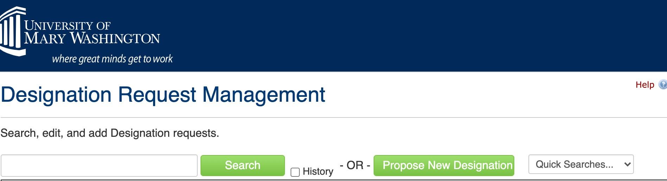
- Select “Propose New designation.” The result should look like the following screen:
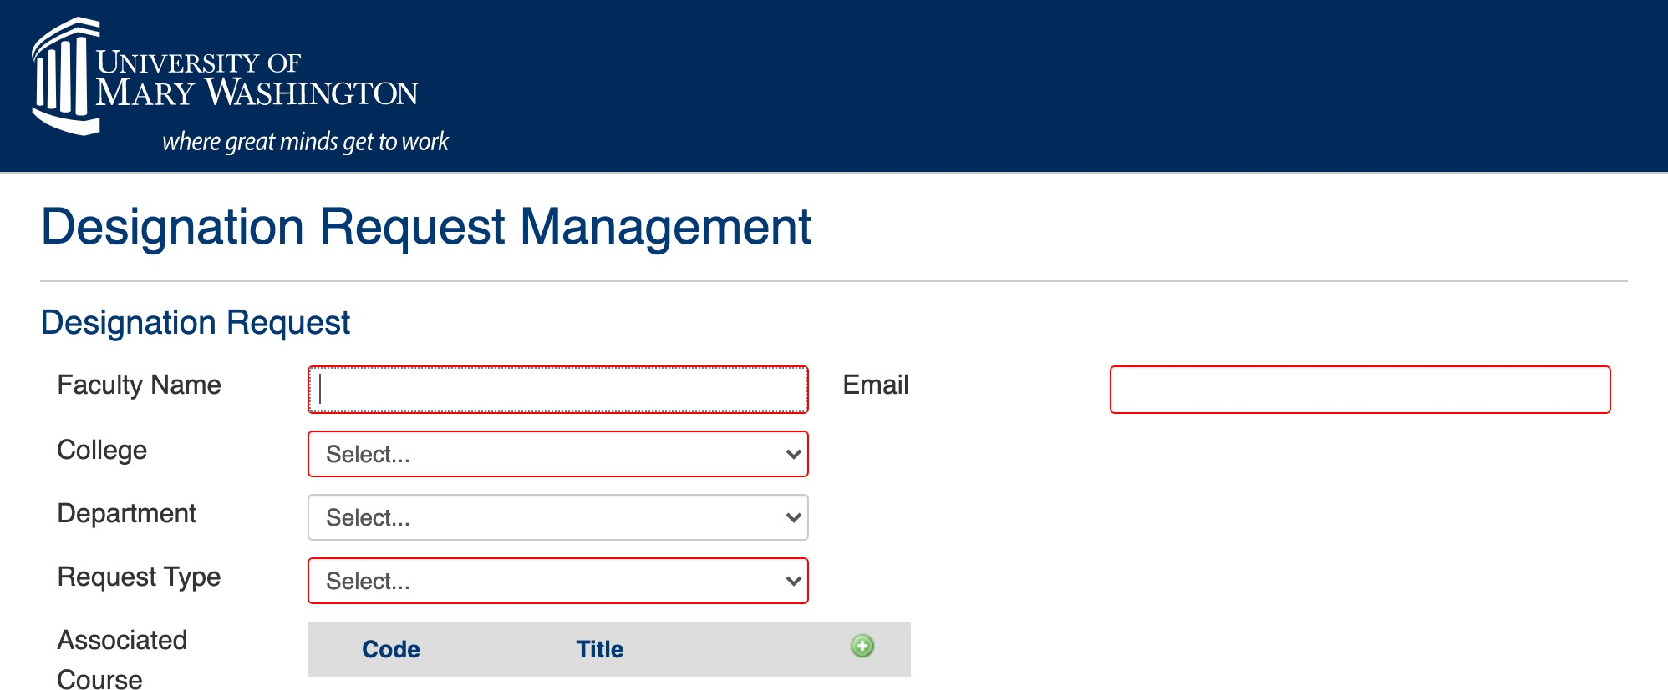
- Fill in name, email, college, and department. Under “Request Type,” select the designation to be added. Under “Associated Course,” click the to search for the existing course to which you want the designation added. For example:
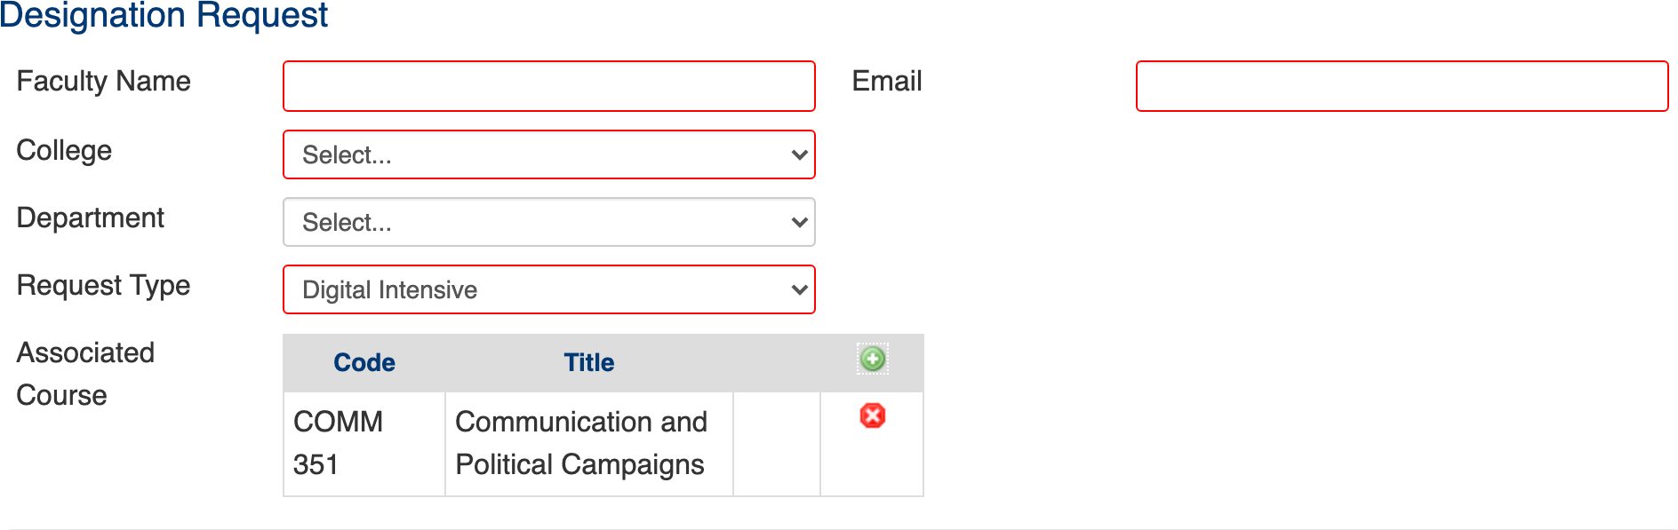

Selecting “Request Type” brings up the additional forms and information required to submit a proposal for the designation in question. Provide the explanations and any attachments as required.

- After all required information is provided, the start workflow button (located at the bottom of the page) is selected to move the proposal to the first reviewer (Department Chair or Associate Dean).

See Appendix A for an explanation of the form fields you will see when submitting a course designation proposal.

See Appendix B for the full display of all steps in the workflow process for a course designation proposal.

APPENDIX A: EXPLANATION OF COURSE DESIGNATION FORM FIELDS

are required and must be completed in order to submit the form.
Fields outlined in red

Faculty Name and Email
The proposing faculty member’s name and UMW email address are to be provided.

College
UMW’s three colleges are the choices available.

Department
The home department of the discipline offering the course. IDIS (interdisciplinary) courses must be associated with a home department. In the Colleges of Business and Education, there is no department.

Associated Course
Here is where you select the existing course to which you want to add an approved designation (such as to make the course Digital Intensive).

Request Type
The particular designation desired for the course. These are the request types available:

  - General Education – all categories including Community Engaged Courses
  - Writing Intensive
  - Speaking Intensive
  - Digital Intensive
  - First-Year Seminar
  - Honors
  - Majority Online Course

Various Course Designation Fields
These will vary depending upon the designation request type selected, there will different items requiring responses. The General Education category has the following separate divisions:

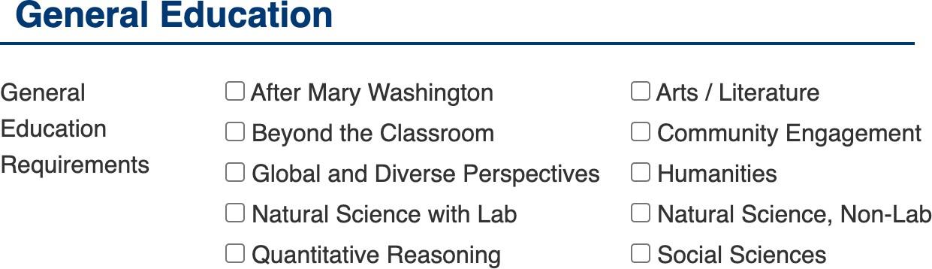

With some designations (such as Speaking or Writing Intensive), there is an option to apply the designation to an individual instructor or to all instructors of the course.

Rationale
An explanation of why the proposed change needs to be made to the course.

APPENDIX B: ADD COURSE DESIGNATION - PROPOSAL WORKFLOW

All steps are the same except for #3, where separate designation committees will get a particular proposal.

If approved | PROCESS STEPS* | If rolled back
 | 1. Proposer logs in to CIM course, completes course designations part of the edit (change) course proposal form, and submits.
 | 2. Department Chair (College of Arts and Sciences) or Associate Dean (College of Business and College of Education) – reviews and either approves proposal or rolls back (to proposer).
 | 3. If approved, proposal goes to Designation Committee. **
 | 4. Designation Committee – reviews and either approves proposal and sends to University Faculty Council or rolls back (to Department Chair or Associate Dean).
 | 5. University Faculty Council – approves proposal or rolls back (to Designation Committee).
 | 6. If approved by University Faculty Council, proposal goes to Registrar’s Office for final check.
 | 7. Registrar adds the attribute to the course section as required or, in the case of General Education “Methods of Investigation,” to the course record in Banner. Designations of individual course sections are not included in the Academic Catalog.

*If other changes are involved, such as changing prerequisite or course description, those steps would occur first in CIM Courses and then the designation proposal would be submitted.

**Designation Committees are:

Digital Intensive Committee (for Digital Intensive Designation Proposals) First Year Seminar Committee (for First Year Seminar Designation Proposals) General Education Committee (for General Education Designation Proposals) Honors Committee (for Honors Designation Proposals)
Distance and Blended Learning Committee (for Majority Online Designation Proposals)
Speaking Intensive Committee (for Speaking Intensive Designation Proposals)
Writing Intensive Committee (for Writing Intensive Designation Proposals)

