PROCEDURES FOR CHANGING COURSES

Guidelines for Submitting Proposals to Change Existing Courses
at the University of Mary Washington

September 2020

TABLE OF CONTENTS

COURSE CHANGES – OVERVIEW OF PROCEDURES 2
EXPEDITED COURSE CHANGES 3
CREDIT HOUR CHANGES 6
CROSS-LIST COURSE AT DIFFERENT LEVEL 8
APPENDIX A: EXPLANATION OF COURSE CHANGE PROPOSAL FORM FIELDS 10
APPENDIX B: EXPEDITED COURSE CHANGE - PROPOSAL WORKFLOW 12
APPENDIX C: CHANGE COURSE CREDIT HOURS - PROPOSAL WORKFLOW 13
APPENDIX D: CROSS LIST COURSE AT DIFFERENT LEVEL - PROPOSAL WORKFLOW 14

Important Procedural Note

All course changes will take effect in the fall semester only. (No proposals will be accepted for a change that would start in the spring or the summer terms.) For a course change action to be implemented beginning in the next fall semester, it must have received all required approvals no later than the posted deadline date, which is usually in late January or early February.

COURSE CHANGES – OVERVIEW OF PROCEDURES

There are three categories of changes that may be made to an existing course. They are: (1) expedited changes, (2) credit hour changes, or (3) cross-listing across course levels.

Expedited changes are editorial revisions of an existing course or the action to inactivate a course. These are usually minor and uncontroversial changes. But they need to be reviewed and acted upon so that everyone will know what is being changed and so that the Academic Catalog may be updated correctly. Expedited changes proceed through a shortened approval process, described below.

Credit hour change proposals seek to adjust the number of credits carried by an existing course. These proposals require a higher level of justification and review before being implemented. These proposal proceed through all steps of the curriculum change process.

Federal requirements and the Principles of Accreditation of the Southern Association of Colleges and Schools Commission on Colleges require that institutions publish and implement policies for determining the amount and level of credit awarded for its courses.

For reference, see UMW’s Credit Hour Policy.

A proposal to cross-list a course across course levels seeks to create a cross-listing between an undergraduate course and a graduate course. These proposals also proceed through all steps of the curriculum change process.

A key consideration is to ensure that the graduate-level course expectations exceed the expectations of the academic content of the undergraduate-level course with which the graduate course is cross-listed. This requirement is in keeping with UMW’s policy on Cross-Level Courses and with the Principles of Accreditation of the Southern Association of Colleges and Schools Commission on Colleges.

For reference, see UMW’s Policy on Cross Level Courses.

EXPEDITED COURSE CHANGES

1. The following course change actions are the only ones handled in the expedited manner:
- Change to a course’s number
- Change to a course’s title
- Change to a course’s catalog description
- Change to a course’s prerequisites
- Cross-list a course at the same level
- Inactivate a course

2. This category of curriculum changes proceeds through an approval process at the college level. Once the College Curriculum Committee (CCC) and the College Faculty Body has approved the change, the proposed change is posted for 10 class days and is available for comment by all members the university faculty. If no comments are made, the expedited course action is approved. If any comments are raised, the proposal will be reviewed by and acted upon by the University Curriculum Committee.

3. Steps for an Expedited Course Proposal:

- Navigate to (URL)

- Click on the EDIT OR PROPOSE A COURSE login and to enter the UMW user name and password.

- Once logged in, the following screen appears:

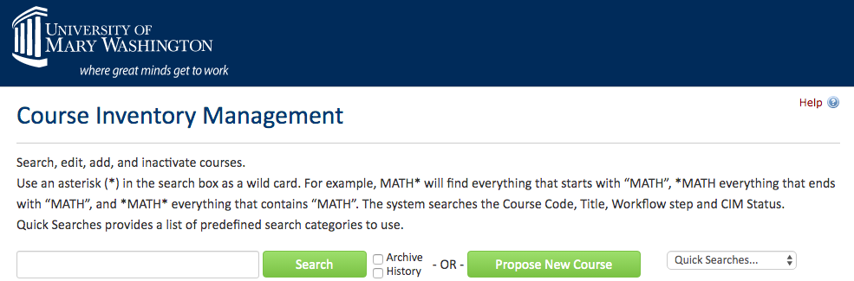

- Enter the four-letter discipline code and number of the course to be changed in the search box and click on search. The result should look like the following screen:
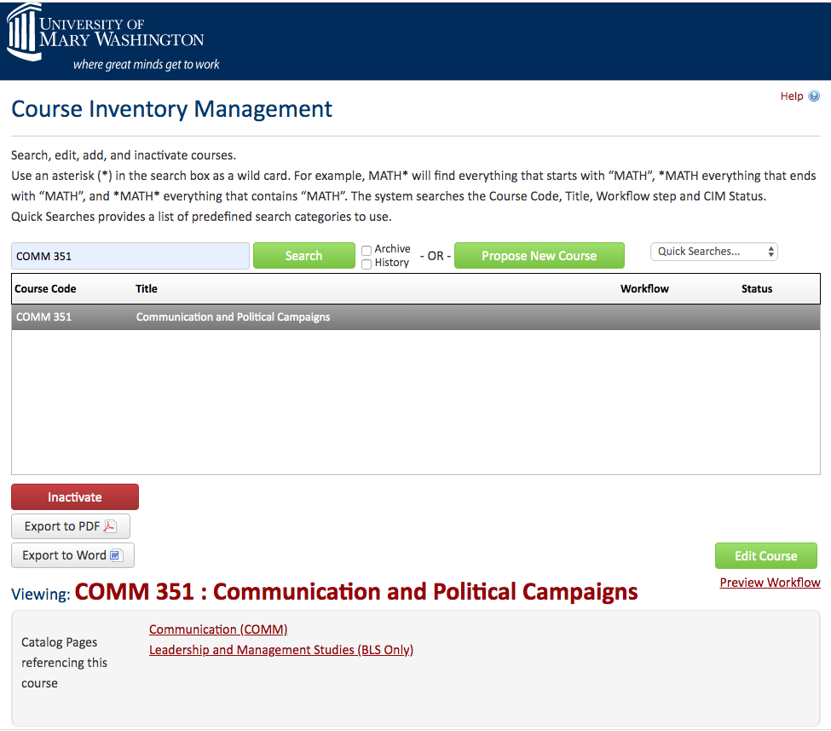

- Select the “inactivate” button to remove this course from the Academic Catalog. The gray area beneath the word “viewing” is called the environmental scan area; it lists the places where this course is referenced in the Academic Catalog. This information might be helpful in deciding the potential consequence of the decision to inactivate the course.

- After clicking on the red button to “inactivate,” the submitter would see this next screen:

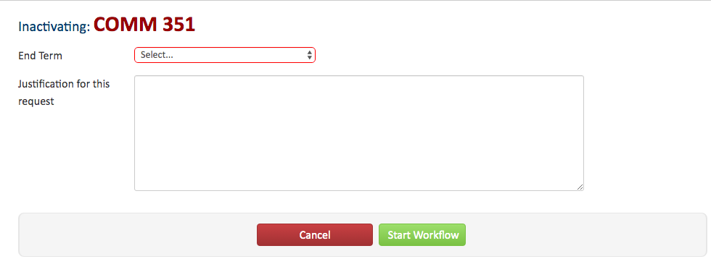

End term is a drop-down menu of upcoming terms to pick from. This is the semester when the course will be made inactive and will no longer appear in the Academic Catalog. In the justification box, the submitter would explain the reasons for making the course inactive.

Once the term is selected and the justification is entered, the submitter hits the “start workflow” button and the proposal is routed to the first approval step, which is either the Department Chair (or Program Director) in the College of Arts and Sciences or the Associate Dean (in the College of Business or College of Education).

- If the action desired was to change some feature of the course – such as its title, description, prerequisites – the submitter would select the green edit course button. A different set of fields would appear.

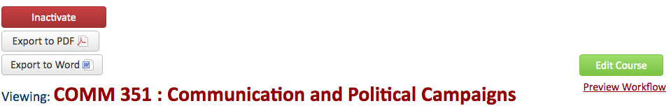

- The submitter would make the desired changes right on the form. After all editorial changes are made, the start workflow button is selected to move the proposal to the first reviewer (Department Chair or Associate Dean). A proposal may be saved for continued work, cancelled, or submitted by selecting “start workflow.”

See Appendix A for an explanation of each of the form fields you will see when editing a course.

Once the proposal is in workflow, changes entered will display as green text. Deletions display as red strikethrough text. See Appendix D for the full display of all steps in the workflow to cross list a course at a different level.

CREDIT HOUR CHANGES

- Navigate to (URL)

- Click on the EDIT OR PROPOSE A COURSE login and to enter the UMW user name and password. Once logged in, the following screen appears:

- Search for the course to be changed. The result should look like the following screen:

- Enter the proposed new credit hours for the course in the box label credit hours. Then, answer this question:

If the answer is NO, this field will appear:

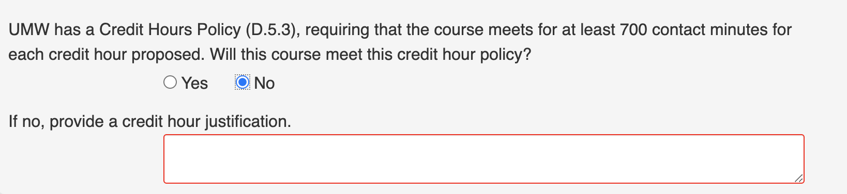

Provide the explanation/justification in the text box.

- The submitter would make the desired changes right on the form. After all required information is provided, the start workflow button is selected to move the proposal to the first reviewer (Department Chair or Associate Dean). A proposal may be saved for continued work, cancelled, or submitted by selecting “start workflow.”

See Appendix A for an explanation of each of the form fields you will see when editing a course.

Once the proposal is in workflow, changes entered will display as green text. Deletions display as red strikethrough text. See Appendix D for the full display of all steps in the workflow to cross list a course at a different level.

CROSS-LIST COURSE AT DIFFERENT LEVEL

- Navigate to (URL)

- Click on the EDIT OR PROPOSE A COURSE login and to enter the UMW user name and password. Once logged in, the following screen appears:

- Search for the course to be changed. The result should look like the following screen:

Find the section of the form to enter a cross listed course. Click on “add” to navigate to a directory of courses. Select the desired course for cross listing. NOTE: for courses cross listed at a different level, the graduate-level course expectations exceed the expectations of the academic content of the undergraduate-level course with which the graduate course is cross-listed.

Provide the explanation for the cross-level course listing in the box titled “justification.”

Include a syllabus that shows how the proposed pairing of cross-level courses will have different and higher-level requirements for the graduate-level course.

- The submitter would make the desired changes right on the form. After all required information is provided, the start workflow button is selected to move the proposal to the first reviewer (Department Chair or Associate Dean). A proposal may be saved for continued work, cancelled, or submitted by selecting “start workflow.”

See Appendix A for an explanation of each of the form fields you will see when editing a course.

Once the proposal is in workflow, changes entered will display as green text. Deletions display as red strikethrough text. See Appendix D for the full display of all steps in the workflow to cross list a course at a different level.

APPENDIX A: EXPLANATION OF COURSE CHANGE PROPOSAL FORM FIELDS

Fields outlined in red are required and must be completed in order to submit the form.

Faculty Name and Email
The proposing faculty member’s name and UMW email address are to be provided.

Academic level
Undergraduate or graduate. Undergraduate courses are numbered 000-499. Graduate courses are 500-599. UMW does not use courses numbered 600 and above.

Discipline
This is the four letter code used to identify subject areas offered at UMW (ENGL, MATH, SPAN, and so forth). The discipline will display as a drop down menu including the four-letter code and the associated disciple name (e.g. SOCG – Sociology).

Department
The home department of the discipline offering the course. IDIS (interdisciplinary) courses must be associated with a home department. In the Colleges of Business and Education, there is no department.

College
UMW’s three colleges are the choices available.

Course Title
This is the full title for the course that will appear in the Academic Catalog. Do not use abbreviations or & (in place of the word and) in this title.

Abbreviated Course Title:
This is a 30 character short title that will appear in the schedule of courses and on the transcript. Abbreviations and & may be used here.

Effective Term
The date when the course action takes effect. For all course changes, the effective term is the fall semester of the next academic year (or a subsequent fall semester).

Number of Credits
The current credit hour value for the course. If the proposal seeks to change the course credit hours, insert the new credit hour number, answer the question about compliance with the credit hour policy and attach an explanation/justification if the response was if the response was “no.”

Catalog Description
The written course description as it will appear in Banner and the Academic Catalog. Course descriptions should be succinct; it is recommended that course descriptions be 50 words or less.

Prerequisite
Courses that must be taken prior to the course in question, or other qualifying conditions necessary before the student may enroll in the course (such as must be a major in a certain field or must have junior/senior standing). Use the four-letter discipline prefix (e.g. MATH) rather than spelling out the discipline name. Have a blank space after the four-letter discipline prefix and the course number. Do not use a period at the end of the list.

Example: MATH 201

Corequisite
Courses that must be taken simultaneously with course in question. Use the four-letter discipline prefix (e.g. MATH) rather than spelling out the discipline name. Have a blank space after the four-letter discipline prefix and the course number. Do not use a period at the end of the list.

Example: MATH 121

Cross Listed Course
For courses offered at the same level, this is the option for the same course to bear two separate discipline codes (e.g. CPSC/DATA 419). Courses cross listed at the same level must have the same title, course description, prerequisites, and corequisites. A note stating “Cross listed as . . .) will appear at the end of the course description in the Academic Catalog.

For courses cross listed across levels (an undergraduate course cross listed with a graduate course), the courses cross level listed may have different titles, descriptions, prerequisites, and corequisites. However, the graduate-level course expectations must exceed the expectations of the academic content of the undergraduate-level course with which the graduate course is cross-listed.

Rationale
An explanation of why the proposed change needs to be made to the course.

APPENDIX B: EXPEDITED COURSE CHANGE - PROPOSAL WORKFLOW

If approved | PROCESS STEPS | If rolled back
 | 1. Proposer logs in to CIM course, completes the edit (change) course proposal form, and submits.
 | 2. Department Chair (College of Arts and Sciences) or Associate Dean (College of Business and College of Education) – reviews and either approves proposal or rolls back (to proposer).
 | 3. If approved, proposal goes to College Curriculum Committee.
 | 4. College Curriculum Committee – reviews and either approves proposal or rolls back (to Department Chair or Associate Dean).
 | 5. College Curriculum Committee – reviews and either approves proposal and sends to College Governance Council or rolls back (to College Curriculum Committee).
 | 6. If approved by College Governance, proposal goes Registrar’s Office for Registrar’s check to ensure the proposal is expedited (or proposal rolls back to College Curriculum Committee).
6. IF EXPEDITED, proposal is posted for a 10 day waiting period.
A. If there are no comments during the 10 day period, proposal is approved. Registrar’s Office initiates Banner sync. Banner and Next Academic Catalog are updated.

B. If comments are made during the 10-day period, Registrar’s Office sends proposal goes to the University Curriculum Committee.
 | 7. University Curriculum Committee – reviews and either approves proposal or rolls back (to College Governance or College Curriculum Committee).
 | 8. If approved by University Curriculum Committee, proposal goes to University Faculty Council.
 | 9. University Faculty Council – approves proposal or rolls back (to University Curriculum Committee).
 | 10. If approved by University Faculty Council, proposal goes to Registrar’s Office to initiate Banner sync.
 | 11. Banner and Next Academic Catalog are updated.

APPENDIX C: CHANGE COURSE CREDIT HOURS - PROPOSAL WORKFLOW

If approved | PROCESS STEPS | If rolled back
 | 1. Proposer logs in to CIM course, completes the edit (change) course proposal form, and submits.
 | 2. Department Chair (College of Arts and Sciences) or Associate Dean (College of Business and College of Education) – reviews and either approves proposal or rolls back (to proposer).
 | 3. If approved, proposal goes to College Curriculum Committee.
 | 4. College Curriculum Committee – reviews and either approves proposal and sends to College Governance or rolls back (to Department Chair or Associate Dean).
 | 5. College Governance – reviews and either approves proposal and sends to University Curriculum Committee or rolls back (to College Curriculum Committee).
 | 6. University Curriculum Committee – reviews and either approves proposal or rolls back (to College Governance or College Curriculum Committee).
 | 7. If approved by University Curriculum Committee, proposal goes to University Faculty Council.
 | 8. University Faculty Council – approves proposal or rolls back (to University Curriculum Committee).
 | 9. If approved by University Faculty Council, proposal goes to Registrar’s Office for final check and to initiate Banner sync.
 | 10. Banner and Next Academic Catalog are updated.

APPENDIX D: CROSS LIST COURSE AT DIFFERENT LEVEL - PROPOSAL WORKFLOW

If approved | PROCESS STEPS | If rolled back
 | 1. Proposer logs in to CIM course, completes the edit (change) course proposal form, and submits.
 | 2. Department Chair (College of Arts and Sciences) or Associate Dean (College of Business and College of Education) – reviews and either approves proposal or rolls back (to proposer).
 | 3. If approved, proposal goes to College Curriculum Committee.
 | 4. College Curriculum Committee – reviews and either approves proposal and sends to College Governance or rolls back (to Department Chair or Associate Dean).
 | 5. College Governance – reviews and either approves proposal and sends to University Curriculum Committee or rolls back (to College Curriculum Committee).
 | 6. University Curriculum Committee – reviews and either approves proposal or rolls back (to College Governance or College Curriculum Committee).
 | 7. If approved by University Curriculum Committee, proposal goes to University Faculty Council.
 | 8. University Faculty Council – approves proposal or rolls back (to University Curriculum Committee).
 | 9. If approved by University Faculty Council, proposal goes to Registrar’s Office for final check and to initiate Banner sync.
 | 10. Banner and Next Academic Catalog are updated.

