Acting on Proposals in the CIM Workflow

1. Workflow refers to the chain of approvals that will lead a proposal from the submission by the initiating user (a faculty member) through the sequence of steps required to secure final approval. Depending upon the type of proposal submitted, the steps in workflow will differ. See the various curriculum action guidelines documents for a listing of workflow steps.

2. When a proposal is submitted, the first approver in workflow receives a system generated email stating that there is a proposal requiring action. Text of the email will go like this:

There are pending course change proposals awaiting your review, including
#title#.
Please visit:
#approveurl#
to review the changes and provide your feedback.

#title# will be filled in with the proposal title; #approveurl# will be a direct link to that proposal in the CIM system.

3. Clicking on the url link takes you to the CourseLeaf Console – you’ll be prompted to log in first, using your UMW username and password. Another way to get to the same place is: https://nextcatalog.umw.edu/courseleaf/approve/

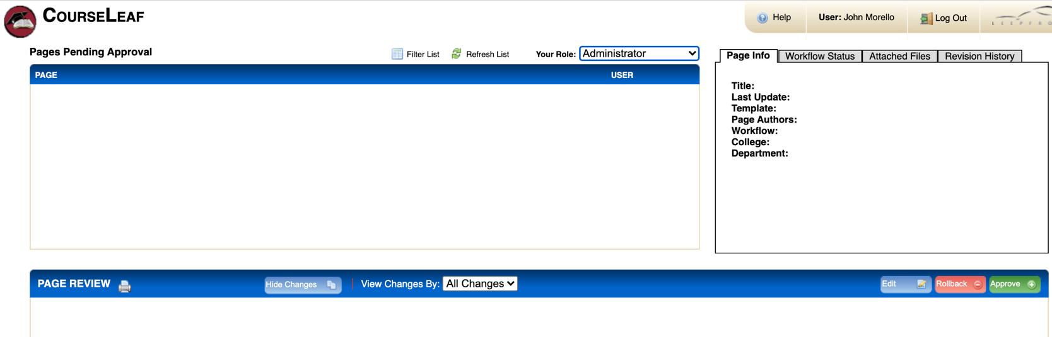
Under Pages Pending Approval will be a listing of all proposals requiring action (each course or program proposal appears as a separate page in CIM). Select the proposal you are acting on (if there are multiple proposals needing your attention all will show up in the list). If you had clicked on the url in the email, you would be viewing that proposal. If other proposals were awaiting action, they would all be listed here as pages pending approval.

The Your Role box will list all the different roles a person has in CIM workflow. The same person, for example, may be a department chair and a curriculum committee chair. Select the role you are acting within given the proposal’s state in workflow.

On the right side of the screen, there are four tabs. Page info provides an overview of the proposal; workflow status records the actions taken in the workflow up to the point the proposal is at and will show future steps needed; attached files will include a list documents provided to support the proposal (a syllabus, for example) with a link to the document; and revision history indicates any changes to the proposal (and who made them) following the point when the proposal was initiated.

4. The blue PAGE REVIEW bar provides the resources used to act on the proposal.

Edit allows the page approver to make changes on the proposal. Anything added shows as green text. Anything deleted shows as red strikethrough. The edit action will bring up the submitted proposal, allowing the reviewer to make needed changes to it. Once edits have been incorporated, at the bottom of the edit screen, there will be two action buttons:

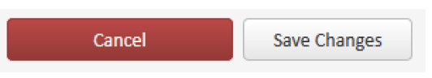

Edits once made will be visible to all who look at the proposal. Another key point to note is that the editing will not move the proposal in workflow; it just makes a change. The approver still needs to act.

Approve sends the proposal to the next step in workflow. Approving after editing sends the proposal forward with changes incorporated.

Rollback returns the proposal to an earlier step in the workflow.

When rollback is selected, a comment box appears. The top part of the box lists all the persons who have previously acted on the proposal; select the individual to whom the proposal will be returned. A comment/reason for the rollback must be included. Any comments entered stay with the proposal, are visible to anyone viewing the proposal in CIM, and may not be changed.

Because the rollback action erases any prior approvals, it is advisable to use this action sparingly. If an approver largely supports the proposal but has a few concerns about details, rather than rolling back a proposal, the approver might contact the previous persons who had acted on the proposal, discuss the concerns, and the either edit (and approve) or, if satisfied with the explanations, approve the proposal with no edits. If things remain at an impasse after discussion outside of the CIM system, then rollback would be the appropriate action. If the approver does not agree with the proposal, it would be rolled back with reasons given.

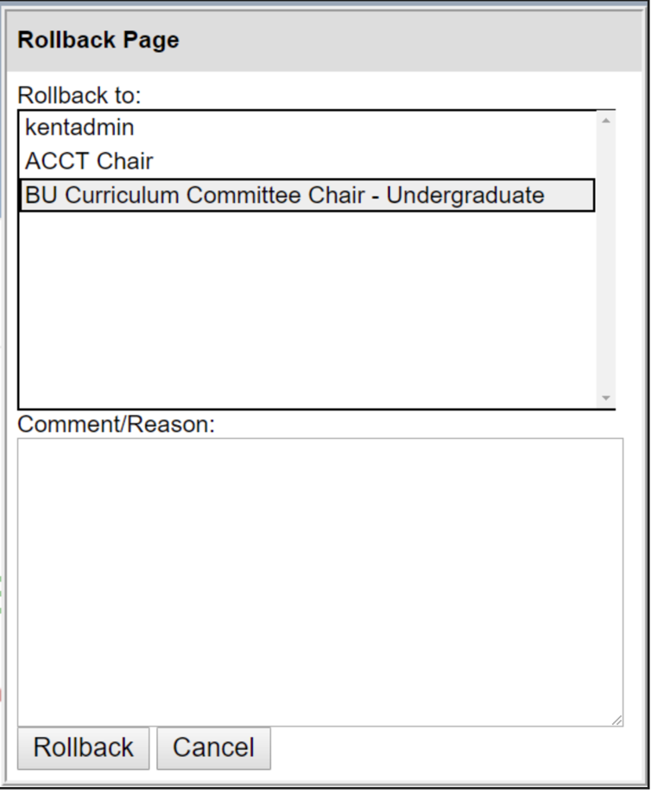

When a proposal is in workflow, the steps in the process are displayed. Items in gray have yet to occur; orange text shows the point where the proposal is in the workflow. Here are several examples. College 01 is CAS, 05 is COB, and 10 is COE. Curriculum Committee and Governance body members receive email notifications of proposals in workflow but do not act in CIM to advance programs in workflow.

New Program Proposal | Edit (Change) Course-Expedited | New Course/Non-Expedited Course Change | Edit (Change) Existing Program
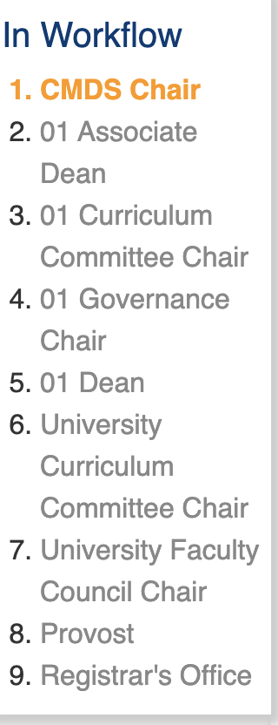 | 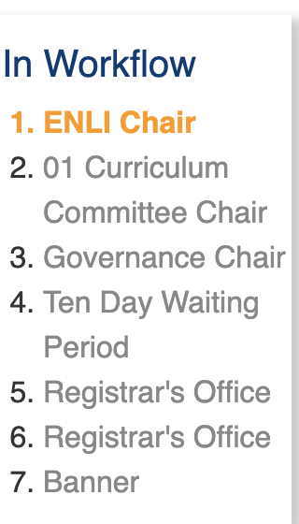 | 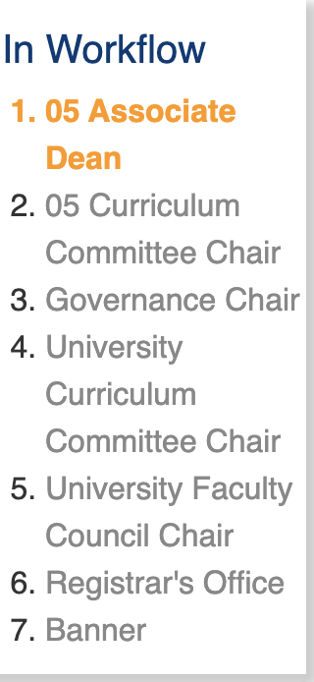 | 