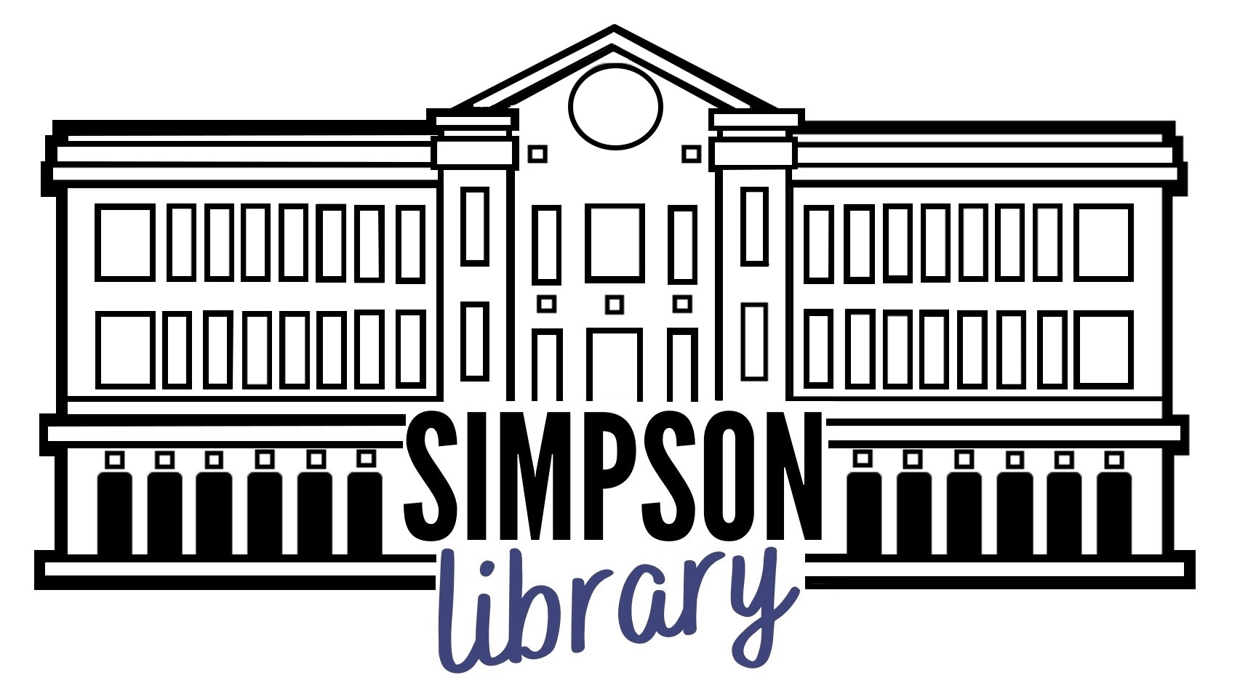

Fall Semester Hours and Services

Hours

Monday – Thursday 8 a.m. to 8 p.m.
Friday 8 a.m. to 5 p.m.
Saturday CLOSED
Sunday 1 p.m. to 8 p.m.
Hours are subject to change

Services
- All services will be provided from the main Service Desk.
- All reserves will be electronic.
- Library materials are held for 72 hours after return.
- All library patrons must wear a mask when in the building.
- Special Collections & University Archives, and the Digital Archiving Lab by appointment.
- Reference librarians available by email and chat, and by appointment for research consultations.
- Need something we don’t have? Interlibrary loan is back in business.

Off Limits for Now
- Treehouses and group study rooms
- ThinkLab
- Simpson Library classroom

Help Us Out!
- Wear a mask.
- Maintain physical distance from library staff and other library patrons.
- Wash your hands.
- One person at a time in restrooms and elevators.
- Wipe down equipment and study spaces before and after use.

For more information, check https://libguides.umw.edu/online

