United States Department of the Interior
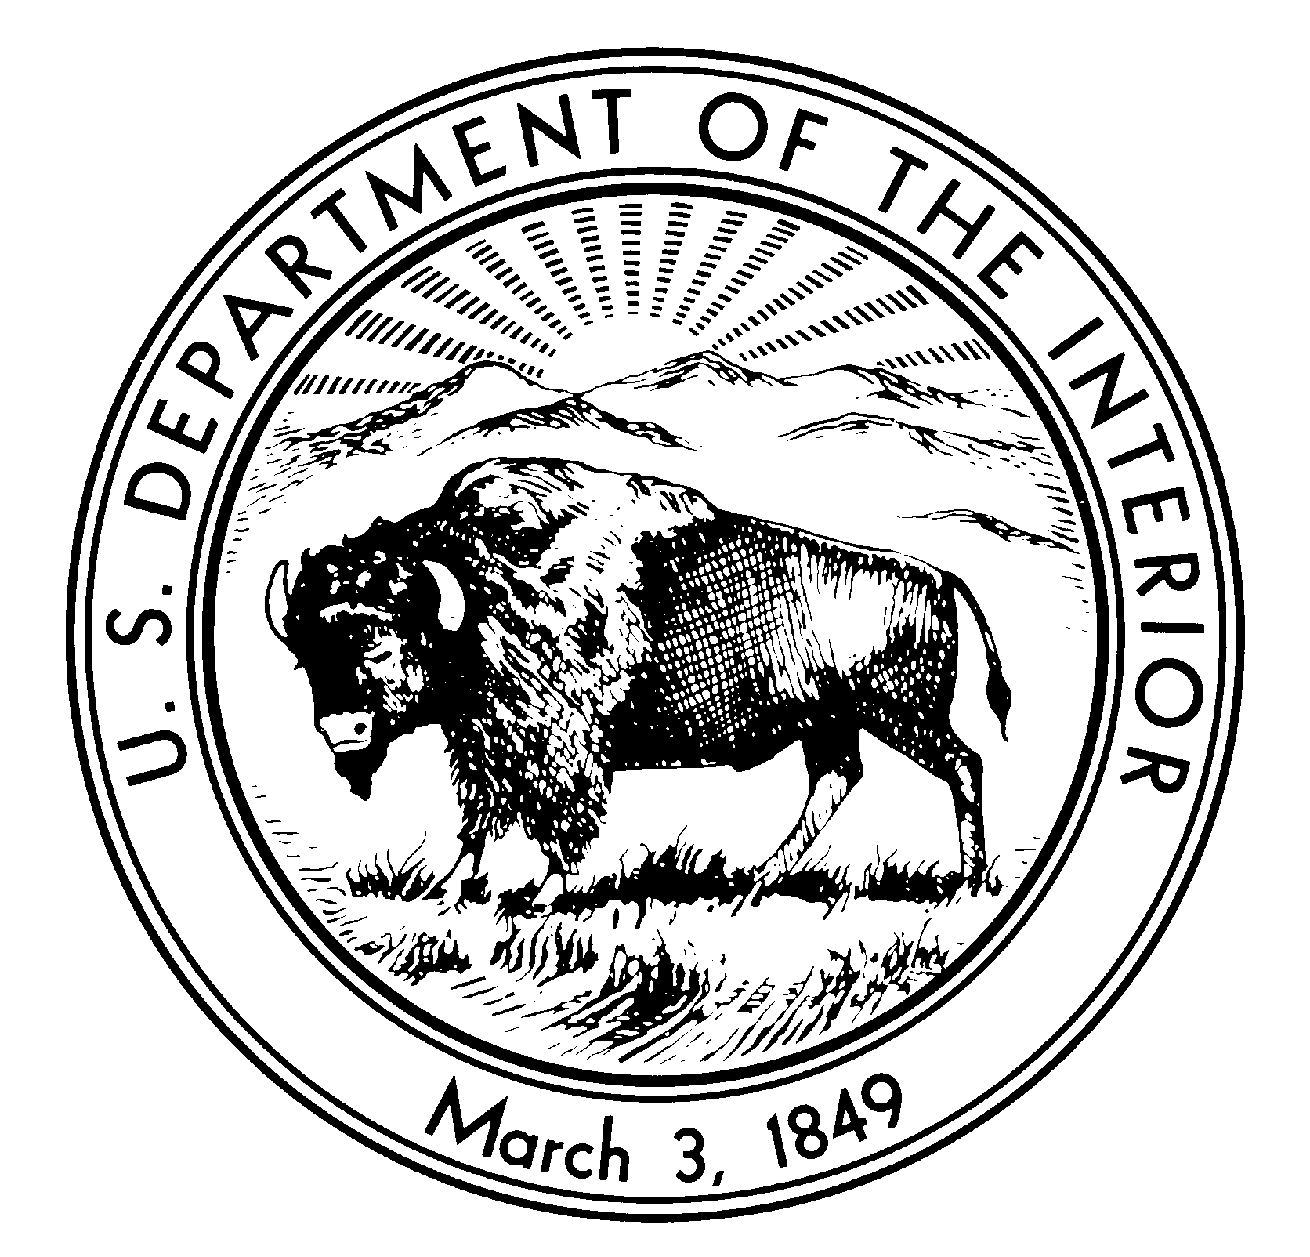

NATIONAL PARK SERVICE
National Capital Region

Chesapeake Watershed Cooperative Ecosystem Study Unit (CW CESU)
And the George Washington Memorial Parkway (GWMP)

Request for Proposals (RFP)

Title: Park-Wide Baseline Biological Inventory for the George Washington Memorial Parkway (GWMP)

A response to this Request for Proposals is due May 15, 2014 via Email to Erik_Oberg@nps.gov.

I am coordinating a park-wide baseline biological inventory here at the George Washington Memorial Parkway (GWMP), a part of the National Park Service in the National Capital Region. We have recently documented our 5,000th species as a result of these efforts.

We have approximately 500 preserved alcohol vials of malaise trap Homopteran (hopper) material collected along the GWMP. Most of the material was collected from Dyke Marsh Wildlife Preserve. This site will soon undergo a 25 million dollar restoration. www.nps.gov/dmwp

We would like to have this material identified to species to the greatest extent possible. Please see attached photo of a typical sample (although many samples contain far fewer specimens). I understand that malaise material captures a wide range of families, many of which have different experts to identify them. We have an amount not to exceed $7,100, including overhead, to accomplish as much work as possible identifying the specimens.

Project products must include:
1) Interim and final reports, submitted as both hard copy and electronically, will include an abstract, introduction, study site, methods, and discussion sections along with a spreadsheet checklist with individual fields for family, genus, and species names, common names (when known), date of collection, habitat and sites documented within the park, a measure of abundance (with notation of state and national rarity), dates of occurrence/observations/flight periods, larval host (if known), range within Virginia, and notes on harmful or non-native species. Interim report due one year after signing of CESU agreement. Final Report due eighteen months after signing of CESU agreement.
2) Review all vials (approx. 500 vials) of preserved specimens currently in the GWMP Natural Resource Management office, mount, label, and determine to species level all unique specimens.
3) Create a synoptic voucher collection representing up to 5 of each species found during the survey. Males and females will be represented when available for species exhibiting sexual dimorphism. These will be delivered in standard size mounting cases using archival-quality materials." Material will be cataloged and housed by the National Park Service. Holotypes may be loaned for new species descriptions through a loan agreement with the National Park Service.
4) Complete and submit Element Occurrence Forms to Virginia Natural Heritage for any occurrences of rare or state-listed species.
5) Provide high resolution (minimum 600 dpi, six megapixel) photos of 50 most common Homopterans of the GWMP. These will be used for education, print and web applications.
6) Make recommendations for a subsequent or follow up, targeted collection of Homopterans groups suspected to occur on the GWMP but not represented in the preserved material.
7) Include GPS location coordinates in Excel format for notable detections or observations recorded during targeted collection efforts. This work will be completed on site by in NPS staff and data entry completed by selected principal investigator.
8) Create a presentation (PowerPoint) describing study results for GWMP staff and the public.
Please email me your proposal with schedule and detailed budget no later than 15 May 2014.

